FUEL COMPONENT OF THE CAPITAL COSTS
OF THE EXTRA-SMALL POWER REACTOR
Y.А. Kazansky
Russia,Obninsk Institute for Nuclear Power Engineering
E-mail: kazansky@iate.obninsk.ru
V.А. Levtchenko
Russia, Obninsk, Experimental Scientific Research and Methodology Center «Simulation Systems» (SSL)
E-mail: levchenkoy@iate.obninsk.ru

The heat power cost based upon the barrel of petroleum cost $_{В} [$/barrel] and heat power generated in burning of the barrel of petroleum β [kcal/barrel] is accepted as the minimal cost of heat power. If the barrel of petroleum cost is 40$ and petroleum calorific power is 10,000 [kcal/kg], the generated heat power cost at power W [MW] and operation time Т [years] is equal to 0.229 W [MW] T [year] М$ or 0.60Δm [kg] М$, where Δm – mass of fission nuclei.
Scenario and cost of the opened fuel cycle consist of the fuel extraction; conversion it into UF6, (74.7 $/kgU); enrichment, (100$/ЕРР); conversion, (12$/kg); manufacturing of FRA, (350$/kg); transportation of the irradiated fuel, (100$/kg); storage (with no chemical processing and Uranium/Plutonium extraction), (accepted cost is 450$/kg). The fuel cost in such cycle also depends on its mass and enrichment.
The Uranium dioxide fuel is long-term leased. To return it back to the initial state (by enrichment and mass as UO₂) in future the following costs are needed: for manufacturing of FRA, transportation of the spent fuel, the chemical processing of the fuel (extraction of Uranium), addition of the burning out fuel, conversion of the chemical composition and radioactive waste disposal. Costs of these works are shown above. Cost of the spent fuel chemical processing (extraction of Uranium) is accepted equal to 1000$/kg.
In the present scenario the cost of the fuel restoration to the initial state does not depend on its enrichment as it is supposed that the chemical processing of the spent fuel cost is equal for power generation in the range of 30–90 MW-year and fuel enrichment in the range of 4.4 – 20%.
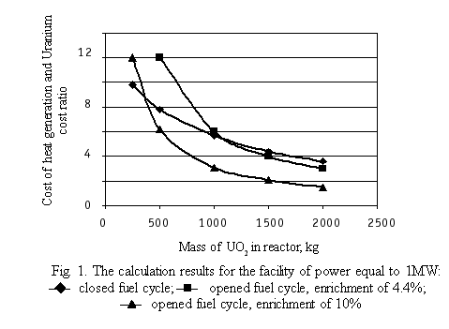

The presented data let to conclude that with Uranium enriched lower than 5% the opened fuel cycle has an advantage over the closed cycle at mass of Uranium in reactor less than 750 kg. At the same time there is a problem of possibility to design the self-controlled and self-protected reactor under such restrictions by mass and enrichment of Uranium.
Table 1
Table Name
Column Header | Column Header | Column Header
Text | Text | Text
Text | Text | Text

References
1. Kazansky Y.А., Levtchenko V.А., Matusevitch Е.S. at al. The Self-Controlled Extra-Small Power Reactor for Heat Generation – «Master of IATE»//Izvestiya vuzov. Yadernaya energentika. – 2003. – № 4.

